OPEN-HOUSE, WRITING POSTER.

Student details:
Name: Minsoo Sohn Class: M 5/1 EP Number: 17
Weebly ID http://30858.weebly.com Mobile number 088-184-8655
Email sms4862@hotmail.com Published file name writingposter

Table of Contents
1. TABLE OF CONTENTS
2. FORMATIVE REQUIREMENTS COVER
3. BRAINSTORM / RESEARCH (ideas, references)
4. POSTER TEMPLATE/ LAYOUT (spatial sequence and format)
5. ORIGINAL DRAFT: (name of peer who revised)
6. REVISED DRAFT: (name of peer who edited)
7. PUBLISHED WORK
8. RUBRIC (self graded)

Publishing Checklist
□ PREVIEW PUBLISHED ON HOMEPAGE
□ COMMENTS POSTED TO LEARNING GROUP’S BLOGS
□ REFERENCES AND CITING COMPLETE

Comments:

Monday 17th January, 2011 Teacher: Neville
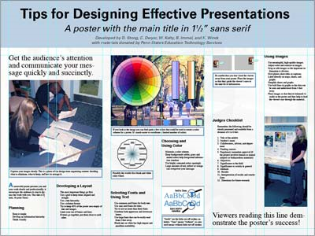
Writing Poster- EP Open House.

Students are expected to produce a writing poster suitable for use in the EP Open House.

Structure Published on student’s weblog.
Focus is on Publishing elements, Spatial sequence and Format.

Procedure Students log on to class weblog http://writingcnep.weebly.com/,formative page and download the following file:
WRITING POSTER
The WRITING POSTER file should be immediately upgraded with student’s details and published on the student’s weblog on Expository page.
Other files and websites necessary to successfully complete the task are listed on the WRITING POSTER CLASS NOTES hand-out.

Students’ production
By Monday 24th January, 2011, students will have completed their work.
Students are required to publish updates of their file, progressively.
Selected posters will be professionally published for the EP Open Day.
Graded work will be published on class weblog for students to download and publish on their own blog..

Objectives
Student’s production will display knowledge of poster elements, promoting a chosen writing process, targeted at an EP Open House audience.

http://www.writingcnep.weebly.com

3. BRAINSTORM / RESEARCH (ideas, references)

4. POSTER TEMPLATE/ LAYOUT (spatial sequence and format)

5. ORIGINAL DRAFT: (name of peer who revised)

6. REVISED DRAFT: (name of peer who edited)

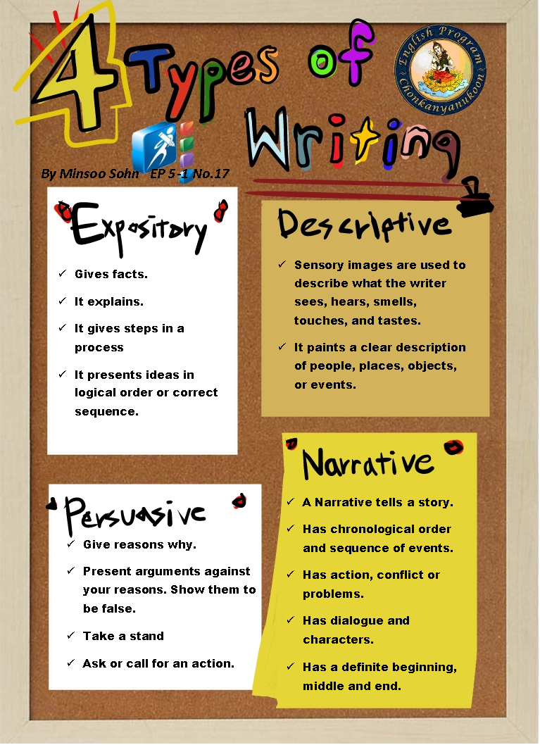

Poster Rubric
Rubric

Objective | Emerging 1 | Developing 2 | Accomplished 3 | Exemplary 4 | Score
PUBLISHING  (Finished look) | The poster demonstrates little or no attention to visual presentation elements and is uninviting to the reader. | Limited attention to visual presentation is demonstrated. The poster creates low desire to be read. Reflects many “lost opportunities”. | Attention to visual presentation elements is strongly exhibited with only a few minor “lost opportunities” | Attention to visual presentation elements is such that the poster has an immediate impact and is highly inviting to the reader. | 10
Uniform spacing and borders.
Appropriate use of font style, sizes and colors.
Appealing use of white space. 40% empty.
Effective integration of text and illustrations, photos, charts, graphs, maps and tables.
Skillful and tasteful use of colors in layout.
The poster targets the correct audience.
Spatial sequence.  Tracking  (double points) | Poster does not display elements of spatial sequence | Contains all elements but does not meet criteria in one or more | All elements are present and complete. | Spatial sequence exceeds requirement
Format  Assimilation of info.  (double points) | Format does not assimilate information appropriately. | Format is appropriate and mostly complete. | Format is appropriate and complete. | Format exceeds requirements.

Teacher Neville. January, 2011. http://writingcnep.weebly.com/

